Virology Portfolio
Clinical Examples of Differential Diagnosis for Selected Viral Infections
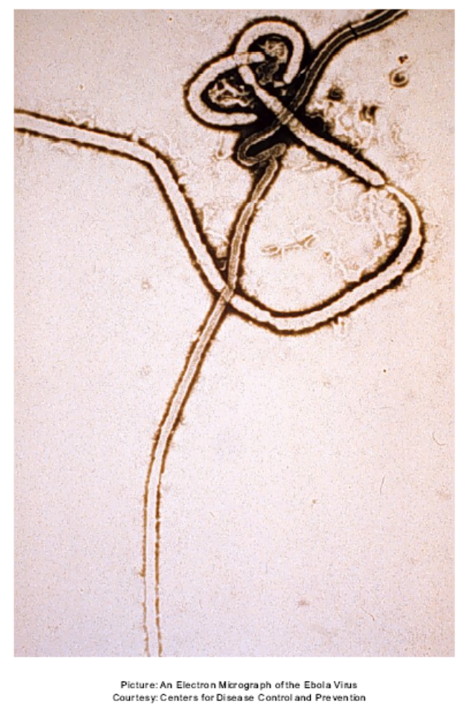
Outline
- Overview
- Severe Acute Respiratory Syndrome (Coronaviridae)
  - General virus information/history
  - Sample Patient - URI
    - Chief Complaint
    - History
    - Differential Diagnosis
- Adenoviridae
  - General virus information/history
  - Sample Patient - URI
- Herpesviridae
  - General virus information/history
  - Sample Patient – Epstein Barr- mononucleosis
- Flaviviridae
  - General virus information/history
  - Sample Patient – hemorrhagic fever
- Filoviridae
  - General virus information/history
  - Sample Patient – hemorrhagic fever
- Appendix
- Overview
Clinicians, regardless of setting, can only spend a limited amount of time with a patient. Frequently clinicians must make a differential diagnosis without the support of time-consuming biochemical assays. Under these constraints it is imperative that clinicians work both quickly and accurately. It could be costly to the patient, the clinic, or the community if a threatening disease were misdiagnosed as something more banal. ^{1,2}
This portfolio will compare the presentation of specific viral illnesses through model patients following certain case definitions. The focus will be placed on the similarities and differences of the illnesses and how to gauge severity.
Coronaviridae and Adenoviridae will be compared in model patients with upper respiratory infections (URI) with specific emphasis placed on severe acute respiratory syndrome (SARS). Flaviviridae and Filoviridae will be compared in model patients with hemorrhagic fevers with specific emphasis placed on the symptoms of the Ebola virus and insect vector transmission of Flaviviridae. Finally, Epstein-Barr virus, of family Herpesviridae and the cause of mononucleosis, will be compared with Adenoviridae again. The brief lecture from the Honors Virology Discussion Panel on Herpesviridae is available in the Appendix. ^{1,2}

- Coronaviridae
The coronavirus is a source of the common cold. It is an enveloped RNA virus. However, severe acute respiratory syndrome (SARS) caused by SARS-associated coronavirus (SARS-CoV) is a new, highly contagious, viral illness. It first appeared as a case of highly contagious, atypical pneumonia in Guangdong province of China in November 2002. The physician that was originally treating patients with the disease fell ill, traveled to relatives in Hong Kong, and communicated the disease. Below is a figure from a Mayo Clinic review article on SARS documenting the original spread of the disease^{1,2,3} :

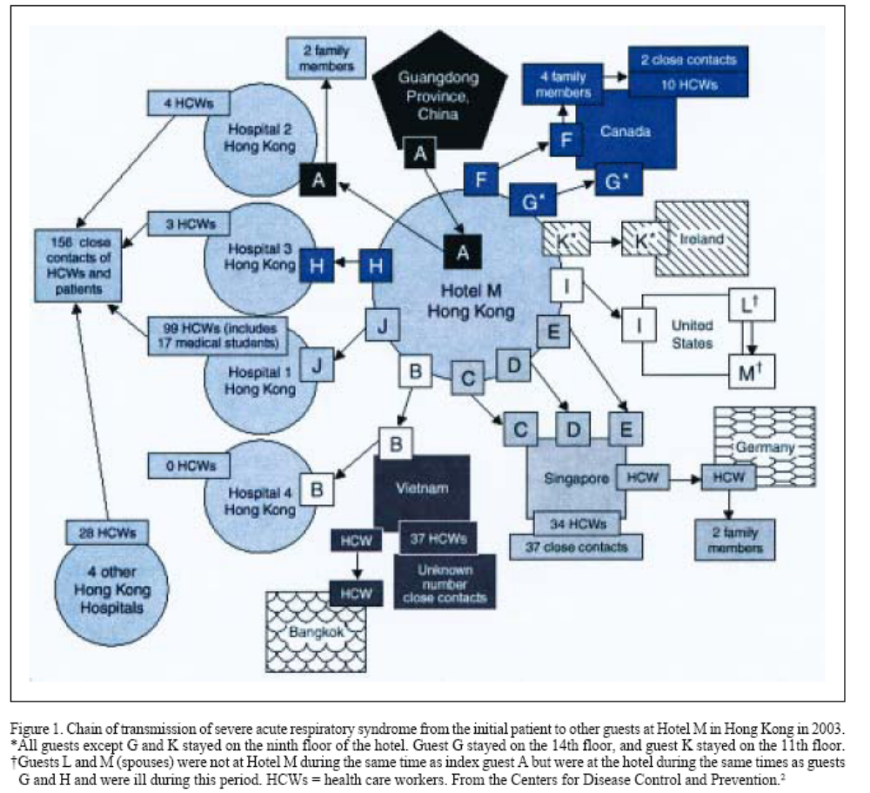

Table 1. Coronaviridae General Characteristics²
Morphology | Pleomorphic, spherical virion
 | Envelope with peplomers
Mean Size | 100nm
Genome | Linear (+) ssRNA, ~30kb, capped & poly-A’d, infectious
Important protiens | Nucleoprotein, peplomer, transmembrane glycoprotein, hemagglutinin-esterase
Replication | In cytoplasm, transcribed to (-)RNA then to mRNA, budding through endoplasmic reticulum and golgi
Model Patient: SARS^{1,2,3}
- Male, 40 yrs
- Chief Complaint
  - Moderate respiratory complaint
    - Temperature >100.4°F (38°C)
    - Cough/Shortness of breath/hypoxia
  - Diarrhea (found in 25% of reported cases)
- Order: Chest X-Ray to confirm pneumonia (CT scan more accurate)
- Order: Pulse oximeter to test for hypoxia
- History
  - Non Smoker
  - Traveled to Southeast Asia 10 days ago (incubation time 2-10 days)
- Interpret Radiology: (See Figure 2)
  - Patchy focal infiltrates, peripheral distribution
  - No pleural effusion
- Order Laboratory Confirmation of Case
  - Detect SARS-CoV antibody during acute illness or >21 days after onset with ELISA
  - Detect SARS-CoV RNA by RT-PCR
- Patient likely has SARS (termed “probable case” without lab tests)
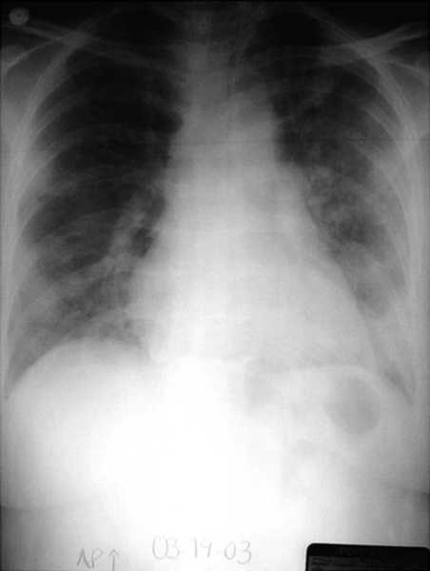
Figure 2. Example SARS chest X-Ray with pneumonia. http://bepast.org/docs/photos/S%20A%20R%20S/sars%20chest%20x-ray.jpg
This patient’s history was the only immediate indicator of a probable case of SARS and not some other form of viral pneumonia. Due to the high transmissibility of SARS it is vital to obtain proper diagnosis (i.e. accurate patient history). See Table 2 below for CDC outline of SARS case definition.^{1,2,3,5}
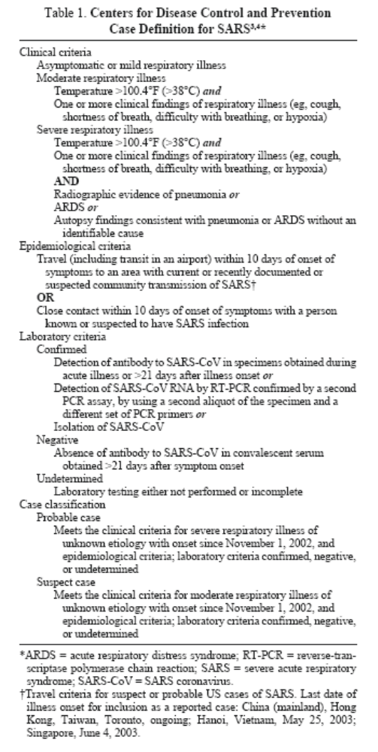
Table 2
- Adenoviridae
Adenoviridae is the fourth most frequent cause of the common cold in children and causes <1% of adult acute respiratory illnesses (medvir). It is, however, a common problem among military recruits. Despite its limited epidemiology compared to rhinovirus (of family Picornaviridae), which causes about 50% of all common colds, adenovirus can cause serious problems, especially in the event of a misdiagnosis.^{1,2}
It would be both costly and ineffective to order lab diagnostics for a patient with only an apparent adenovirus infection. However, a danger lies in the misdiagnosis of a common cold for SARS. The difference between these infections cannot be cheaply determined, serologically, within a clinical setting so the physician must rely on good observation and history-taking skills to get the correct differential diagnosis.^{1,2}

Table 3. Adenoviridae general information ^{2,5}
Morphology | Icosahedral,~85nm, nonenveloped, 12 fibers at verticies
Genome | Linear dsDNA, 36-38kb
Replication | Transcription, replication & assemble occurs in nucleus
Diseases | Respiratory, ocular, genitourinary, enteric, pneumonia/meningoencephalitis in immunocompromised
Epidemiology | Direct contact, fecal-oral, waterborne. Persistent infection can occur, virus inhabits adenoids, can be shed for months to years.  http://www.cdc.gov/ncidod/dvrd/revb/respiratory/eadfeat.htm

Model Patient: Adenovirus – pharyngitis^{1,2}
- Male, 18 yrs
- Chief Complaint
  - Fever, 100°F
  - Malaise
  - Nasal congestion, mild to moderate
  - Sore throat, moderate to severe
  - Weight loss, loss of appetite
  - Symptoms for past 4 days
- Examination
  - Tonsillitis, enlarged lymph nodes
- History
  - No recent travel
  - Still in college
  - National guardsman, has not yet had army shots
- Order pharyngeal swab -> ELISA
  - Monoclonal Ab Ident adenovirus serotypes OR
- Order pharyngeal swab -> Immunoflourescence OR
- Order pharyngeal swab -> culture in Hela, look for CPE=swollen, refractile clustered cells, may be time consuming but most diagnostic
- Reference: White, D. O. and F. J. Fenner. Medical Virology. Ed. 4. 1994: Academic Press Ltd, London.
One of the biggest indicators that a patient has an adenovirus as opposed to some other common cold pathogen is military recruit status. Like SARS-CoV, efficient diagnosis is dependent on good history taking and essentially good patient interview skills.
- Herpesviridae – Epstein-Barr Virus
All herpes viruses can persist in their hosts as an episome in the nucleus of their specific harboring cell. Epstien-Barr virus persists in the lymphocyte. In addition to mononucleosis (or glandular fever) it can cuase progressive lymphoproliferative disease in immunocompromised patients, Burkitt’s lymphoma, and nasopharyngeal carcinoma. ^{1,2}
A problem in differential diagnosis could be its similarity to other upper respiratory illnesses, like that of adenoviridae and coronaviridae.^{1,2}

Table 4. Herpesviridae General Characteristics²
Morphology | Spherical virion, icosahedral capsid,
 | Envelope
Mean Size | 120-200nm
Genome | Linear dsDNA, 125-229kbp
Replication | In nucleus, envelope from nuclear budding
 | Productive infection cytocidal, latent with genome persisting in nucleus

Model Patient: EBV, Epstein-Barr – mononucleosis^{1,2,5}
- Female, 17 yrs
- Chief Complaint
  - Fever, 100°F
  - Headache
  - Malaise
  - Sore throat (pharyngitis), severe w/ swelling
  - Nasal congestion, mild
  - Weight loss, loss of appetite
  - Symptoms have persisted for past 7 days
- Examination
  - Enlarged lymph nodes
  - Enlarged spleen (maybe)
- History
  - Non smoker
  - No recent travel
  - No sexual experience
  - Boyfriend of 3 months
- Order blood work THEN
  - Reveals elevated WBC w/ atypical lymphocytes
- Order monospot
  - Sheep RBC agglutinates EBV Ab
    - Rapid screening for mono
Reference: Gladwin, M. and B. Trattler. Clinical Microbiology Made Ridiculously Simple: Edition 3. 2006: MedMaster Inc, Miami

Epstein-Barr virus is both typical and asymptomatic in young children, but due to increased public health, infection has been largely delayed to adolescence. It is commonly known as “kissing disease” since it can be spread by saliva among young men and women. It has a long incubation period and presents with flu like symptoms and headaches for up to 3 weeks. ^{1,2}
Since serious complications can develop and the disease can be easily spread, proper diagnosis is very important.
V. Flaviviridae
Formerly an “arbovirus,” or arthropod-borne virus, family flaviviridae includes several potentially devastating pathogens. Some of the most harmful flaviviruses cause hemorrhagic fevers. ^{1,2,4}
The dengue virus has been around for centuries but since the Second World War, rapid urbanization has allowed Aedes aegypti mosquito populations to proliferate. Control of the mosquito vector is the best method of controlling this old virus. A. aegypti mosquitoes favor stagnant pools, typically in artificial structures like discarded tires or buckets. In developing nations, these debris are amply found, especially on the fringes of urban areas where mosquito control is poorest. ^{1,2,4}
A major clinical problem with the diagnosis of dengue hemorrhagic fever is the similarity its symptoms bear to a host of tropical and non-tropical diseases.^{1,2,4}

Table 5. Flaviviridae General Characteristics²
Morphology | Spherical virion
 | Envelope with peplomers
Mean Size | 40-50nm
Genome | Linear (+) ssRNA, ~11kbp, capped & looped, infectious
Replication | In cytoplasm, polyprotein translated from genomic RNA, released as cytoplasmic vesicles

Model Patient: Flavivirus- Dengue Hemorrhagic Fever/Shock^{1,2,4,5}

- Male, 21 yrs
- Chief Complaint
  - Fever,103 °F, sudden onset, persisted for past 4 days
  - Malaise with muscle ache
  - Frontal headache, behind the eyes
  - Joint pain
  - Rash on trunk
- History
  - College student
  - Has yellow fever vaccine
  - Recently went on volunteer trip to Honduras for community service
- Examination
  - Decided to keep patient at hospital with intravenous fluids overnight for further observation and potential treatment of possible diagnoses:
    - Measles, rubella, influenza, typhoid, leptospirosis, malaria, non-specific viral infection
- Defervesence
  - Patient’s fever drops
  - Blood pressure drops
  - Recent blood test shows his platelet count is plummeting below 100,000/mm³
  - Skin hemorrhages (petechiae) and purpuric lesions develop
  - Gums begin to bleed
  - GI hemorrhaging
  - Patient has viral hemorrhagic fever, may procede to hemorrhagic shock syndrome if not treated
- Order Serological assay -> hemagglutination-inhibition
  - Easy, quick
  - Antibodies persist longer but only show up after 5-6 days of illness OR
- Order Serological assay -> Complement fixation
  - not widely used OR
- Order Serological assay -> Neutralization test
  - Most sensitive and specific for dengue fever
  - Uses plaque neutralization OR
- Order Serological assay -> ELISA
  - Anti-dengue IgM detectable within 5 days of acute illness (for 80%)
  - Quick, easy, accurate, although less accurate than heagglutination-inhibition OR
- Order Serological assay -> Virus isolation
  - Uses mammalian cell cultures, not practical
- Reference: White, D. O. and F. J. Fenner. Medical Virology. Ed. 4. 1994: Academic Press Ltd, London.
- Reference: Gubler, D.J. Dengue and Dengue Hemorrhagic Fever. Clinical Microbio Reviews. 1998(11): 480-496.

While dengue hemorrhagic fever and dengue shock syndrome are typical in children under the age of 15 in developing nations, it has been reported in older adults as well (dengue). Once again history-taking is important. This patient was only visiting a developing nation in the tropics and was up to date with many of his vaccines. There is no effective dengue vaccine. Another concern with hemorrhagic fever is that the hemorrhaging and shock may start before the appropriate serological/lab test can be performed. Inaccurate antibody detection may occur if certain tests are performed too soon during the fever phase. ^{1,2,5}
VI. Filoviridae – hemorrhagic fever
Family filoviridae, which includes Marburg virus, Ebola-Zaire, Ebola-Sudan, and Ebola-Reston virus, can cause severe, fatal hemorrhagic fevers and liver necrosis. The hemorrhagic fevers were first observed in Marburg, Germany, but later, a massive outbreak occurred in Zaire and Sudan with more than 430 deaths. While there have been no human cases in the United States, shipments of monkeys in Reston, Virginia became infected and died of a filovirus of similar serology. ^{1,2,5}
Transmission, in all outbreaks, appears to be due to contact with bodily fluids although aerosol spread has not been ruled out. While African green monkeys appear to be carriers of the virus, they are not the natural reservoir. They are merely amplifying hosts. The true reservoir has not been identified.^{1,2,5}
Examining diagnosis of this extremely virulent illness may be debatable since prevention and control of outbreaks is more valuable. One can still consider a hypothetical situation of a patient carrier bringing the disease to a metropolitan area.^{1,2,5}

Table 6. Filoviridae General Characteristics²
Morphology | Filamentous rod, helically wound nucleocapsid
 | Lipid envelope with peplomers
Mean Size | 80nm diameter, 800-1000nm length
Genome | Linear (-) ssRNA, 19kb,
Replication | In cytoplasm, forms large inclusion bodies, budding from plasma membrane
 | Culture in Vero (African green monkey) cells
Sensitivity | Sensitive vs. lipid solvents, anti-enveloped virus solvents, can retain infectivity at room temperature for days

Model Patient: Filovirus – Ebola hemorrhagic fever^{1,2,5}

- Male, 30 yrs
- Chief Complaint
  - Fever, 103°F
  - Malaise
  - Muscle weakness, ache
  - Headache, dizziness
  - Sore throat, moderate
  - Symptoms began suddenly within past 24 hours and have worsened
- Examination
  - Reveals maculopapular rash
    - Small, pimple-like, bumps- typical of scarlet fever (Strep. pyogens infection)
- History
  - Visiting his brother for past week
  - Originally from Zaire
  - Gives guided tours through rural African areas
  - Suddenly became ill
- Keep in hospital for isolated observation, potential biohazard
  - Within a matter of hours -> symptoms worsen further
  - Severe vomiting and diarrhea
    - Blood in vomit and stool
  - Patient becomes prostrate with pain in trunk and throat
  - Petechiae and brusies develop
  - Gums begin to bleed, blood in urine\
  - Shock with tremors
  - Encephalopathy, hepatitis symptoms, renal failure
  - General case fatality 50-90%
- Quarantine the hospital! Burn everything that may be contaminated! Find the brother! Biosafety Level 4 hazard.
- Order- serological confirmation -> PCR
  - Virus antigen in clinical specimen
  - Lab diagnosis is too hazardous to perform
- Reference: White, D. O. and F. J. Fenner. Medical Virology. Ed. 4. 1994: Academic Press Ltd, London.
- Reference: Centers for Disease Control and prevention. Disease Conditions. Last Updated 2/08/08. Accessed 4/20/08. http://www.cdc.gov/DiseasesConditions/az/

The average incubation period for Ebola is 5-10 days with a maximum and minimum of 2-21 days. It is likely that this patient was exposed to the bodily fluids of the African green monkey (or some unknown natural reservoir) during safari in rural Africa. Because the period of infectivity may precede the onset of symptoms, many other individuals in the area of the medical center may have been exposed and should be quarantined.^{2,5}
VII. Appendix
Script for Presentation
I’ll be talking about differential diagnosis from a clinician’s perspective. I’m going to present two model patients with their chief complaints and then work through their respective histories to get a preliminary diagnosis. After that we’ll pretend to order tests and get results back to confirm a differential diagnosis.
Clinicians have very little time to communicate with patients. Thus it is very important that they be both concise and informed. Medical students are taught ways of getting information out of patients quickly because many illnesses present with very similar symptoms. In a clinical setting you may be confronted with something that appears mundane but is actually not.
We’ll start with a 17 year old female who- [Page 2 CC]
Another patient, an 18 year old male presents with – [Page 3 CC]
Upon physical examination of the female you find – [Page 2 exam]
Upon examination of the male you find – [Page 3 exam]
Model Patient: EBV, Epstein-Barr - mononucleosis
- Female, 17 yrs
- Chief Complaint
  - Fever, 100°F
  - Headache
  - Malaise
  - Sore throat (pharyngitis), severe w/ swelling
  - Nasal congestion, mild
  - Weight loss, loss of appetite
  - Symptoms have persisted for past 7 days
- Examination
  - Enlarged lymph nodes
  - Enlarged spleen (maybe)
- History
  - Non smoker
  - No recent travel
  - No sexual experience
  - Boyfriend of 3 months
- Order blood work THEN
  - Reveals elevated WBC w/ atypical lymphocytes
- Order monospot
  - Sheep RBC agglutinates EBV Ab
    - Rapid screening for mono
- Reference: Gladwin, M. and B. Trattler. Clinical Microbiology Made Ridiculously Simple: Edition 3. 2006: MedMaster Inc, Miami.
Model Patient: Adenovirus – pharyngitis
- Male, 18 yrs
- Chief Complaint
  - Fever, 100°F
  - Malaise
  - Nasal congestion, mild to moderate
  - Sore throat, moderate to severe
  - Weight loss, loss of appetite
  - Symptoms for past 4 days
- Examination
  - Tonsillitis, enlarged lymph nodes
- History
  - No recent travel
  - Still in college
  - National guardsman, has not yet had army shots
- Order pharyngeal swab -> ELISA
  - Monoclonal Ab Ident adenovirus serotypes OR
- Order pharyngeal swab -> Immunoflourescence OR
- Order pharyngeal swab -> culture in Hela, look for CPE=swollen, refractile clustered cells, may be time consuming but most diagnostic
- Reference: White, D. O. and F. J. Fenner. Medical Virology. Ed. 4. 1994: Academic Press Ltd, London.

References
- Gladwin, M. and B. Trattler. Clinical Microbiology Made Ridiculously Simple: Edition 3. 2006: MedMaster Inc, Miami.
- White, D. O. and F. J. Fenner. Medical Virology. Ed. 4. 1994: Academic Press Ltd, London.
- Sampathkumar, P., Temesgen, Z., Smith T., and Thompson R. L. SARS: Epidemiology, Clinical Presentation, Management, and Infection Control Measures. Mayo Clin Proc. 2003: 78: 882-890.
- Gubler, D.J. Dengue and Dengue Hemorhagic Fever. Clinical Microbio Reviews. 1998(11): 480-496.
- Centers for Disease Control and prevention. Disease Conditions. Last Updated 2/08/08. Accessed 4/20/08. http://www.cdc.gov/DiseasesConditions/az/

